PROJECTREPORT

# CRMAPPLICATIONTHATHELPSTOBOOKAVISASLOTVIEW

1. INTRODUCTION
   1. OVERVIEW

**CRM** systemlikeAgentics helps youinaccumulatingallyourbusinessdata. **CRM** system makes organizing data and processingstudent VISA applications as simple as a child’s play. You can also uploadvarious student-related data. All the data are stored in the same place. Thus,the**CRM**systemhelpsin avoidinganymisplacementofdata.

* 1. PURPOSE

Thiscanincludepersonaldetails,visa applicationhistory,andotherrelevantinformation.Thismakesiteasyforvisaofficerstoaccesstherequiredinformationquickly and accurately.

Thiscanhelpreducetheworkloadonvisaofficersandensurethatcustomersreceivetimely updates abouttheir visa applicationstatus.

Thiscanhelpvisaofficersprovidebettercustomerserviceandaddressanyconcernsorissues thatcustomers may have.

Thiscanhelpvisaofficersprovidebettercustomerserviceandaddressanyconcernsorissues thatcustomers may have.

1. PROBLEMDEFINITION&DESIGNTHINKING
   1. EMPATHYMAP

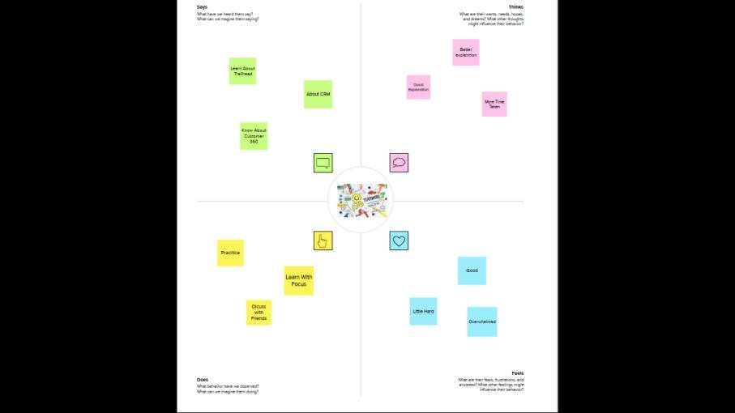

* 1. 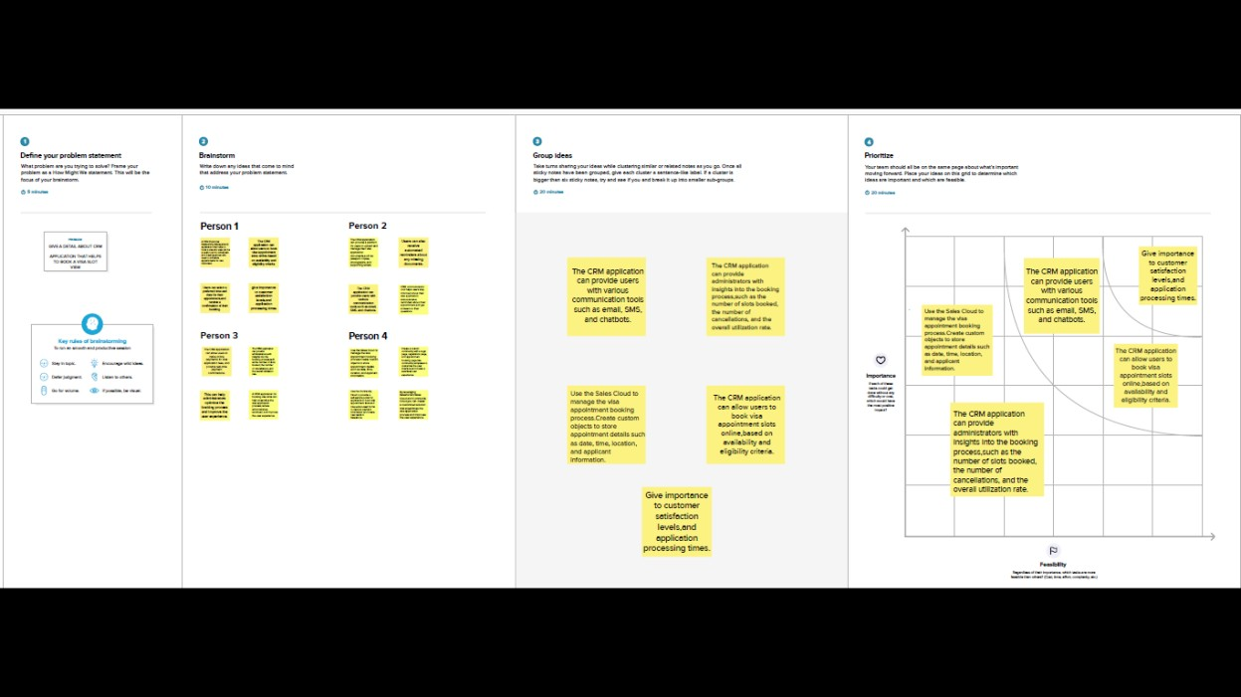IDEATION&BRAINSTORMMAP

# RESULT

* 1. **DATAMODEL**

|  |  |  |  |  |
| --- | --- | --- | --- | --- |
| **OBJECTNAME** | **FIELDSINTHEOBJECT** | | | |
| PASSPORT |  | | | |
|  | FIELDLABEL | DATATYPE |  |
| 1.Full Name2.PassportNumber3.Permanent Address | Text |
| 1.ContactNumber | Number |
| VISASLOT |  | | | |
|  | FIELDLABEL | DATATYPE |  |
| 1.Location2.PassportNmuber3.Visa slotnumber | Text |
| 1.Time | Time |

|  |  |  |  |  |  |  |
| --- | --- | --- | --- | --- | --- | --- |
| PAYMENT |  | | | | | |
|  | FIELDLABEL | | DATATYPE | |  |
| 1.Payment mode2.Transaction ID3.CancelTransaction  4. Visa slotnumber | | Text | |
| 1.CardNumber | | Number | |
| RESCHEDULE/CANCEL |  | | | | | |
|  | | FIELD  LABEL | | DATATYPE |  |
| 1.PassportNumber2.Location3.Cancel4.Status | | Text |
| 1.Time | | Time |

# ACTIVITY&SCREENSHOT

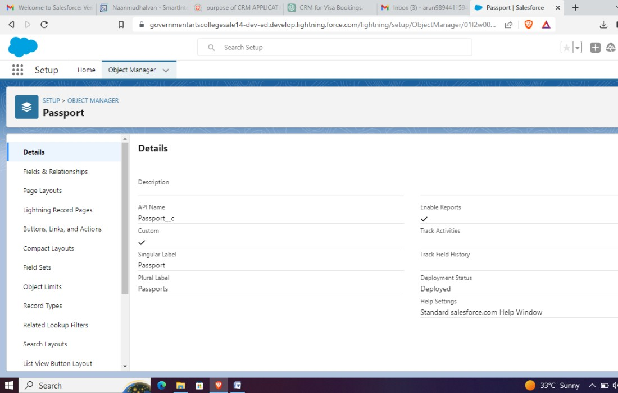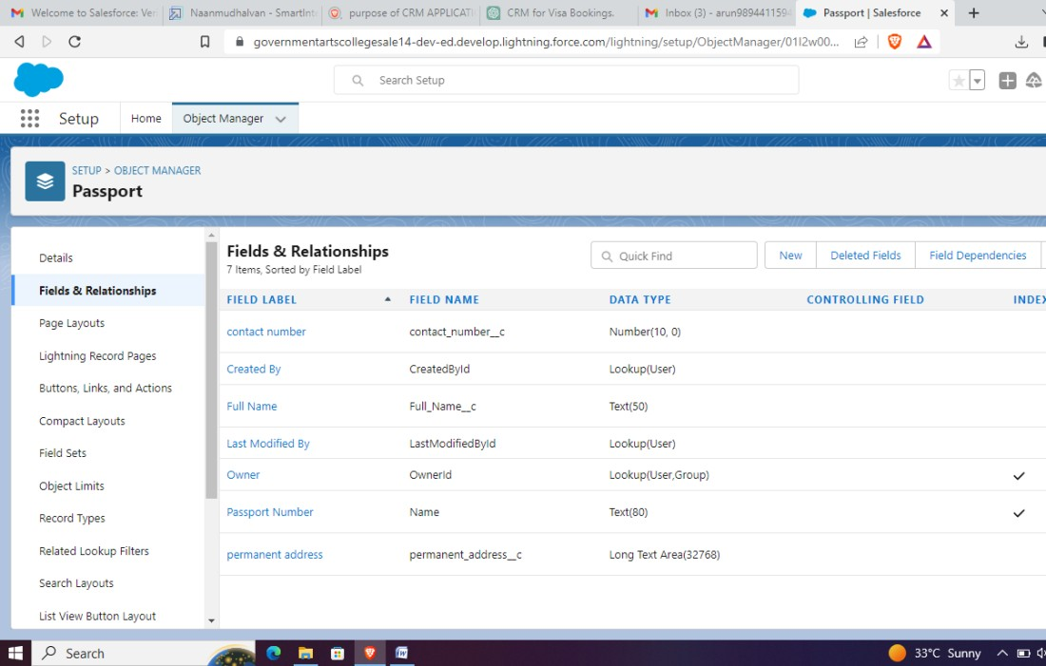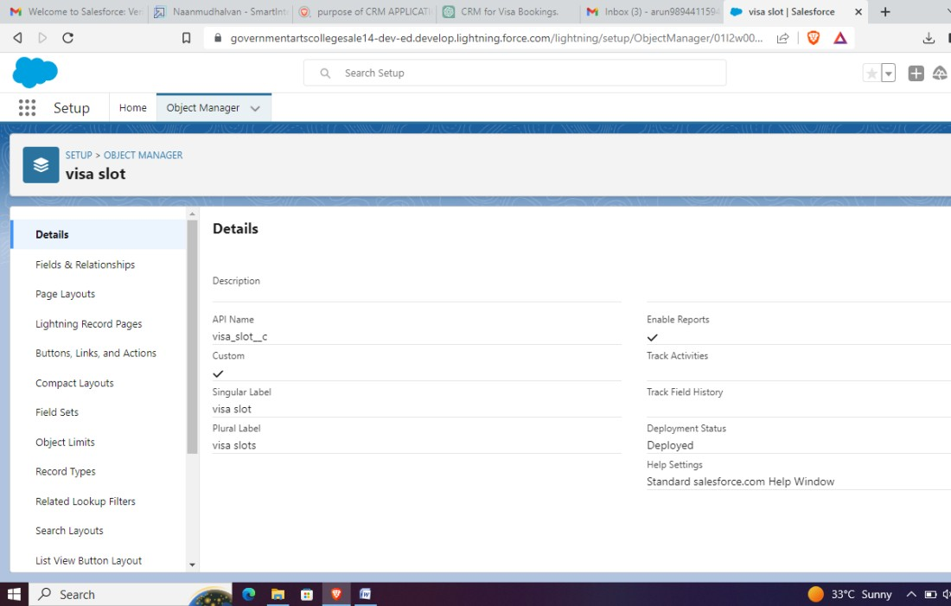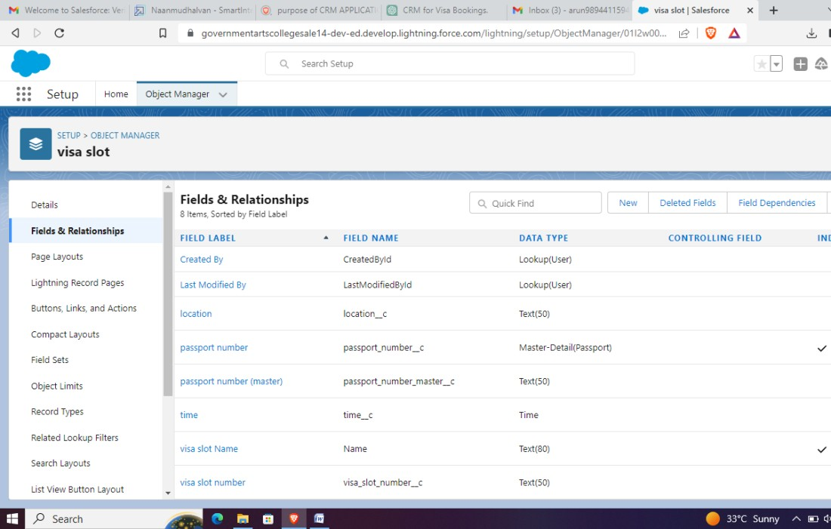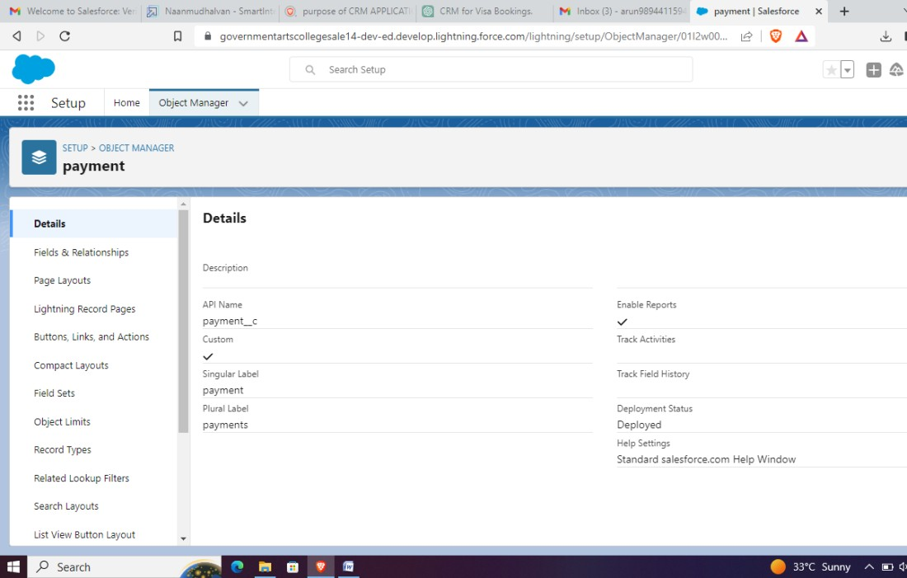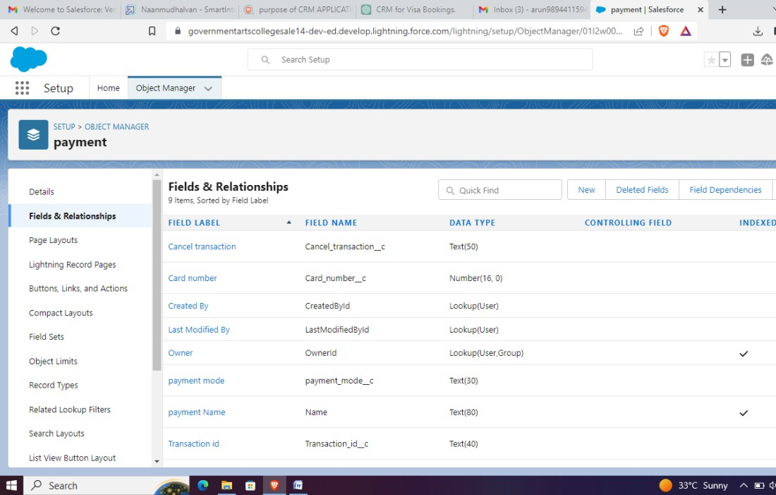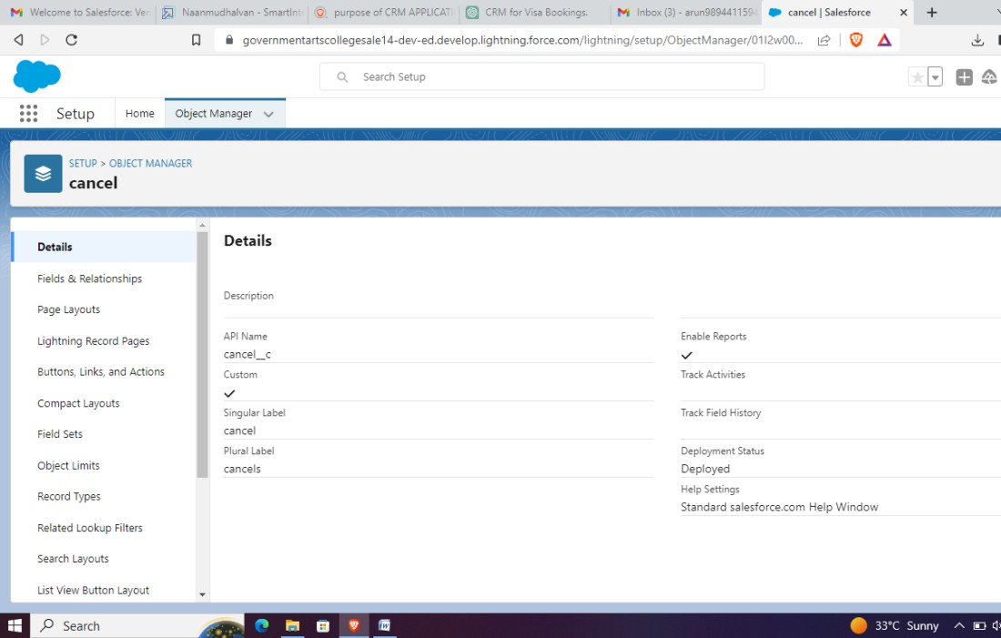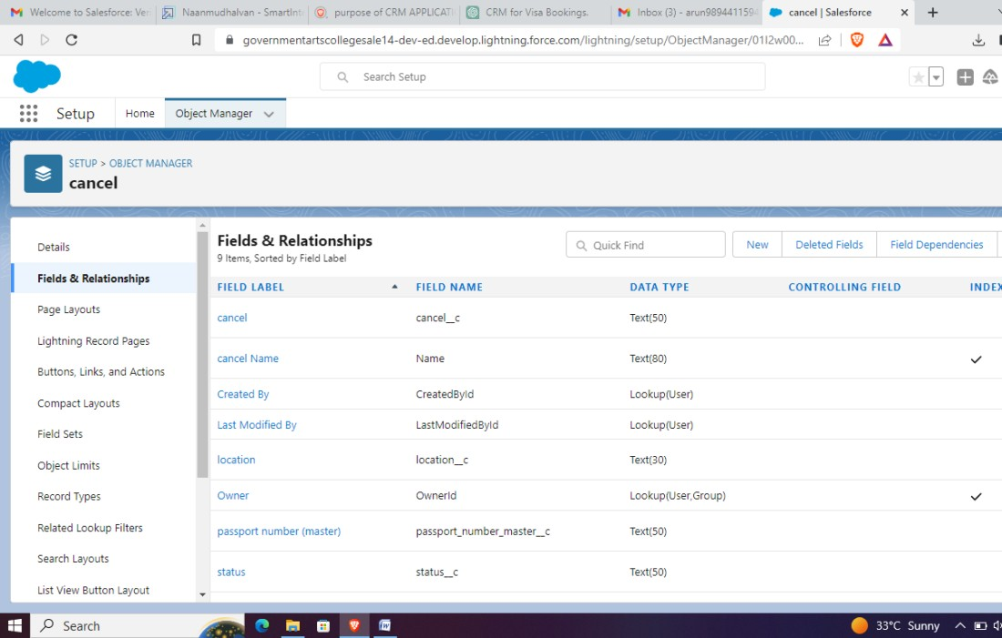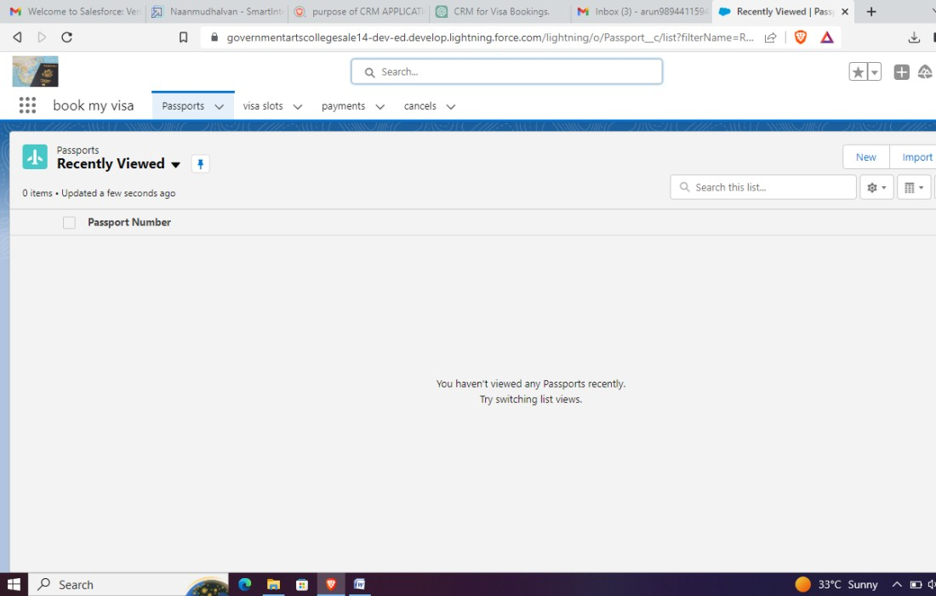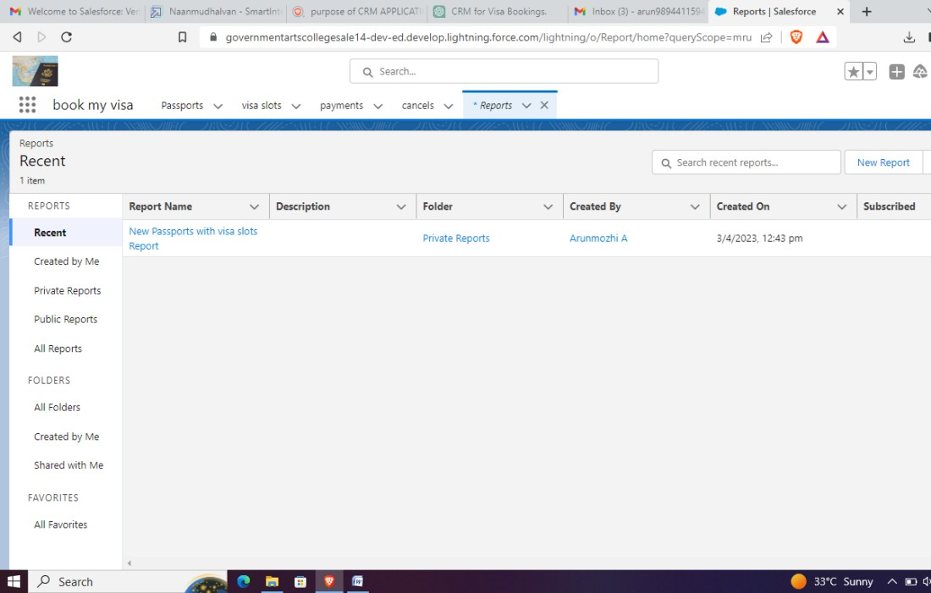

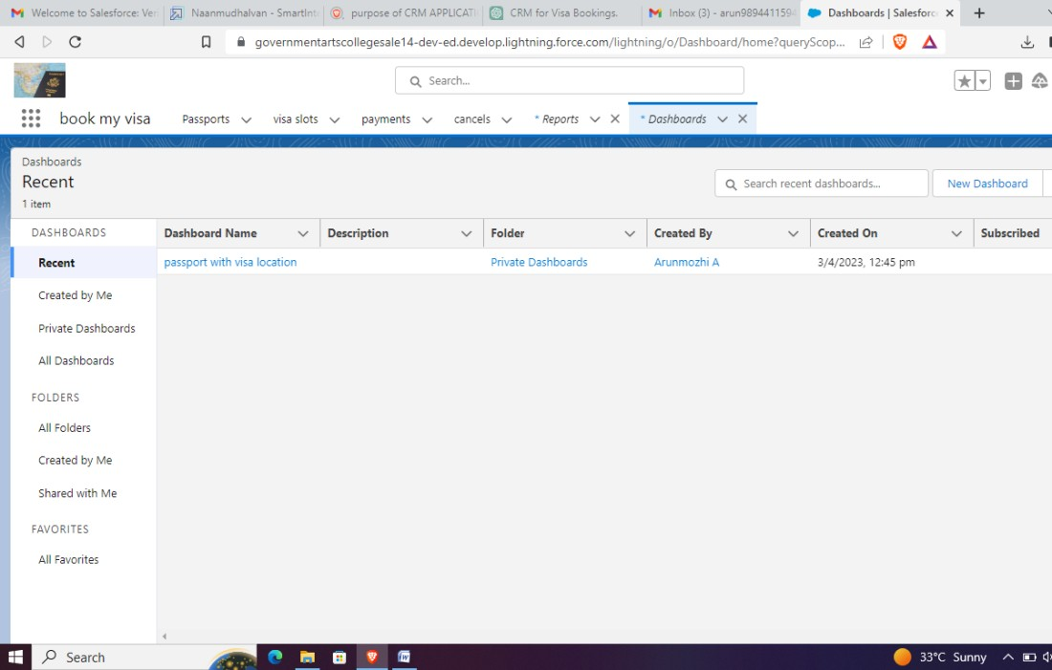

1. **TRAILHEADPROFILEPUBLICURL**

Team Lead :[https://trailblazer.me/id/gd03](https://trailblazer.me/id/gd03" \o "https://trailblazer.me/id/gd03)

TeamMember1:[https://trailblazer.me/id/dasfi](https://trailblazer.me/id/dasfi" \o "https://trailblazer.me/id/dasfi)

TeamMember2:[https://trailblazer.me/id/ps04](https://trailblazer.me/id/ps04" \o "https://trailblazer.me/id/ps04)

# ADVANTAGES

A CRM application can help you streamline the visa application process,making it easier and more convenient for your customers to book their visaslots. This can result in a better overall customer experience, which can helpbuildcustomerloyaltyandimproveyourreputation.

A CRM application can help you keep track of all the information related toeachvisaapplication,includingcustomerdetails,visa requirements,andappointmentschedules.

A CRM application can help you communicate with your customers moreeffectively, providing them with timely updates on their application statusandanychangestothevisarequirements

ACRMapplicationcanhelpyoustoresensitivecustomerinformationsecurely, reducingtheriskof data breachesandidentitytheft.

# DISADVANTAGES

CRMapplicationscanbecomplextosetupanduse,particularlyforuserswhoare not familiar with the technology or who have limited technical skills. Thiscanleadtoasteeplearningcurveandmayrequireadditionaltrainingforstaffmembers.

If you are using an existing system to manage visa applications, integrating anew CRM application may require significant time and effort to ensure thatall data is transferred correctly and that the new system is fully integratedwithexistingprocesses.

WhilemostCRMapplicationsarehighlycustomizable,makingchangestothesystem can be time-consuming and may require the assistance of technicalexperts.This canlimit yourabilitytomake changes quicklyandeasily.

WhileaCRMapplicationcanimprovedatasecurity,itcanalsoposeasecurityriskifnotproperlysecured.Ifyoursystemishackedorotherwisecompromised,customerdatacouldbestolenorusedforfraudulentpurposes.

# APPLICATIONS

Onlinebooking:ACRMapplicationcanbeusedtocreateanonlineportalforvisa applicantstobooktheirvisaslots

Thiscanhelpreducewaittimesandimprovecustomer satisfaction.

A CRM application can be used to send automated emails or SMS messagesto visa applicants, providing them with reminders about their appointments,updatesonvisa requirements,andotherrelevantinformation

# CONCLUSION

CRM application can help you streamline your visa booking process, improvecustomer satisfaction, and increase efficiency, making it a valuable tool foranyvisaserviceprovider.

CRM application can offer many benefits for visa service providers, there arealso potential costs and challenges associated with implementing and usingthis technology effectively. It is important to carefully consider your needsandresourcesbeforeinvestinginaCRMapplication,andtoworkcloselywithtechnicalexperts toensure thatyoursystemisproperly configuredandsecured.

# FUTURESCOPE

the future scope for CRM application to book a visa slot is exciting, with newtechnologies and trends poised to transform the way visa service providersoperate and deliver value to their customers. By staying ahead of theseemerging trends and embracing new technologies, visa service providers candifferentiatethemselvesinacompetitivemarketandprovideamoreseamlessandsatisfyingvisaapplicationexperience fortheircustomers.